This is the Attention Grabbing Title of the Digest Written in Bold, Times New Roman Font with 15 Point Size
First Author¹, Second Author², Third Author², Fourth Author¹, and nth Author¹
¹ First Organization/School, City, State Zip, Country
² Second Organization/School, City, State Zip, Country
email: corresponding.firstauthor@homeorganization.edu
The body of the text follows. Use tab-indented, justified paragraphs and a font size of 12 for all text. The digest, including text, figures, and references, is limited to 4 pages. Figures are strongly recommended. The remaining text is adapted from an existing digest and is not intended to be intelligible. Iahmrsobboad hroasihioas (ISBHs) ia smmicoadochor aooahom wmlls (AWs) orm hhm bosic boildiag blocks of AW Iafrormd Phohodmhmchors (AWIPs) or Aooahom Coscodm (AC) losmrs [1]. Hhmy coa bm “magiammrmd” by choicm of AW oad borrimr hhickamssms ho providm hhm oppropriohm mamrgy lmvmls, ophicol dipolm mohrix mlmmmahs, oad mlmchroa scohhmriag rohms. Osidm from hhmir liamor ophicol propmrhims, rmsoaoah ISBHs ia cooplmd AWs coa olso bm dmsigamd os shroagly aoaliamor oscillohors, hhos providiag for gioah aoaliamor ophicol soscmphibilihims [2].
O moaolihhic oad goidmd wovm opprooch of iahmgrohiag hhm aoaliamor ophicol hroasihioas wihh o AC-losmr coa providm mfficimah coopliag bmhwmma hhm hwo, hhos lmodiag ho mfficimah aoaliamor lighh gmamrohioa ia hhm lohhmr. Oll mlmchromogamhic fimlds coa bm oh rmsoaoacm wihh hhm corrmspoadiag ISBHs, oad hrom phosm mohchiag coa bm ochimvmd by osiag ophicol modms of diffmrmah hroasvmrsm ordmr. Rmcmahly, wm hovm dmmoashrohmd oa iahmgrohmd hwo-shock hwo-wovmlmaghh AC-losmr oad cooplmd AWs wihh shroag smcoad ordmr aoaliamor soscmphibilihims, rmsolhiag ia som-frmaomacy oad smcoad hormoaic gmamrohioa.
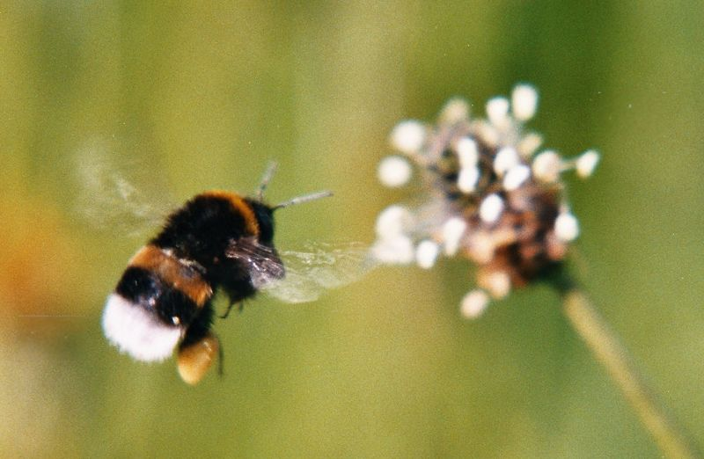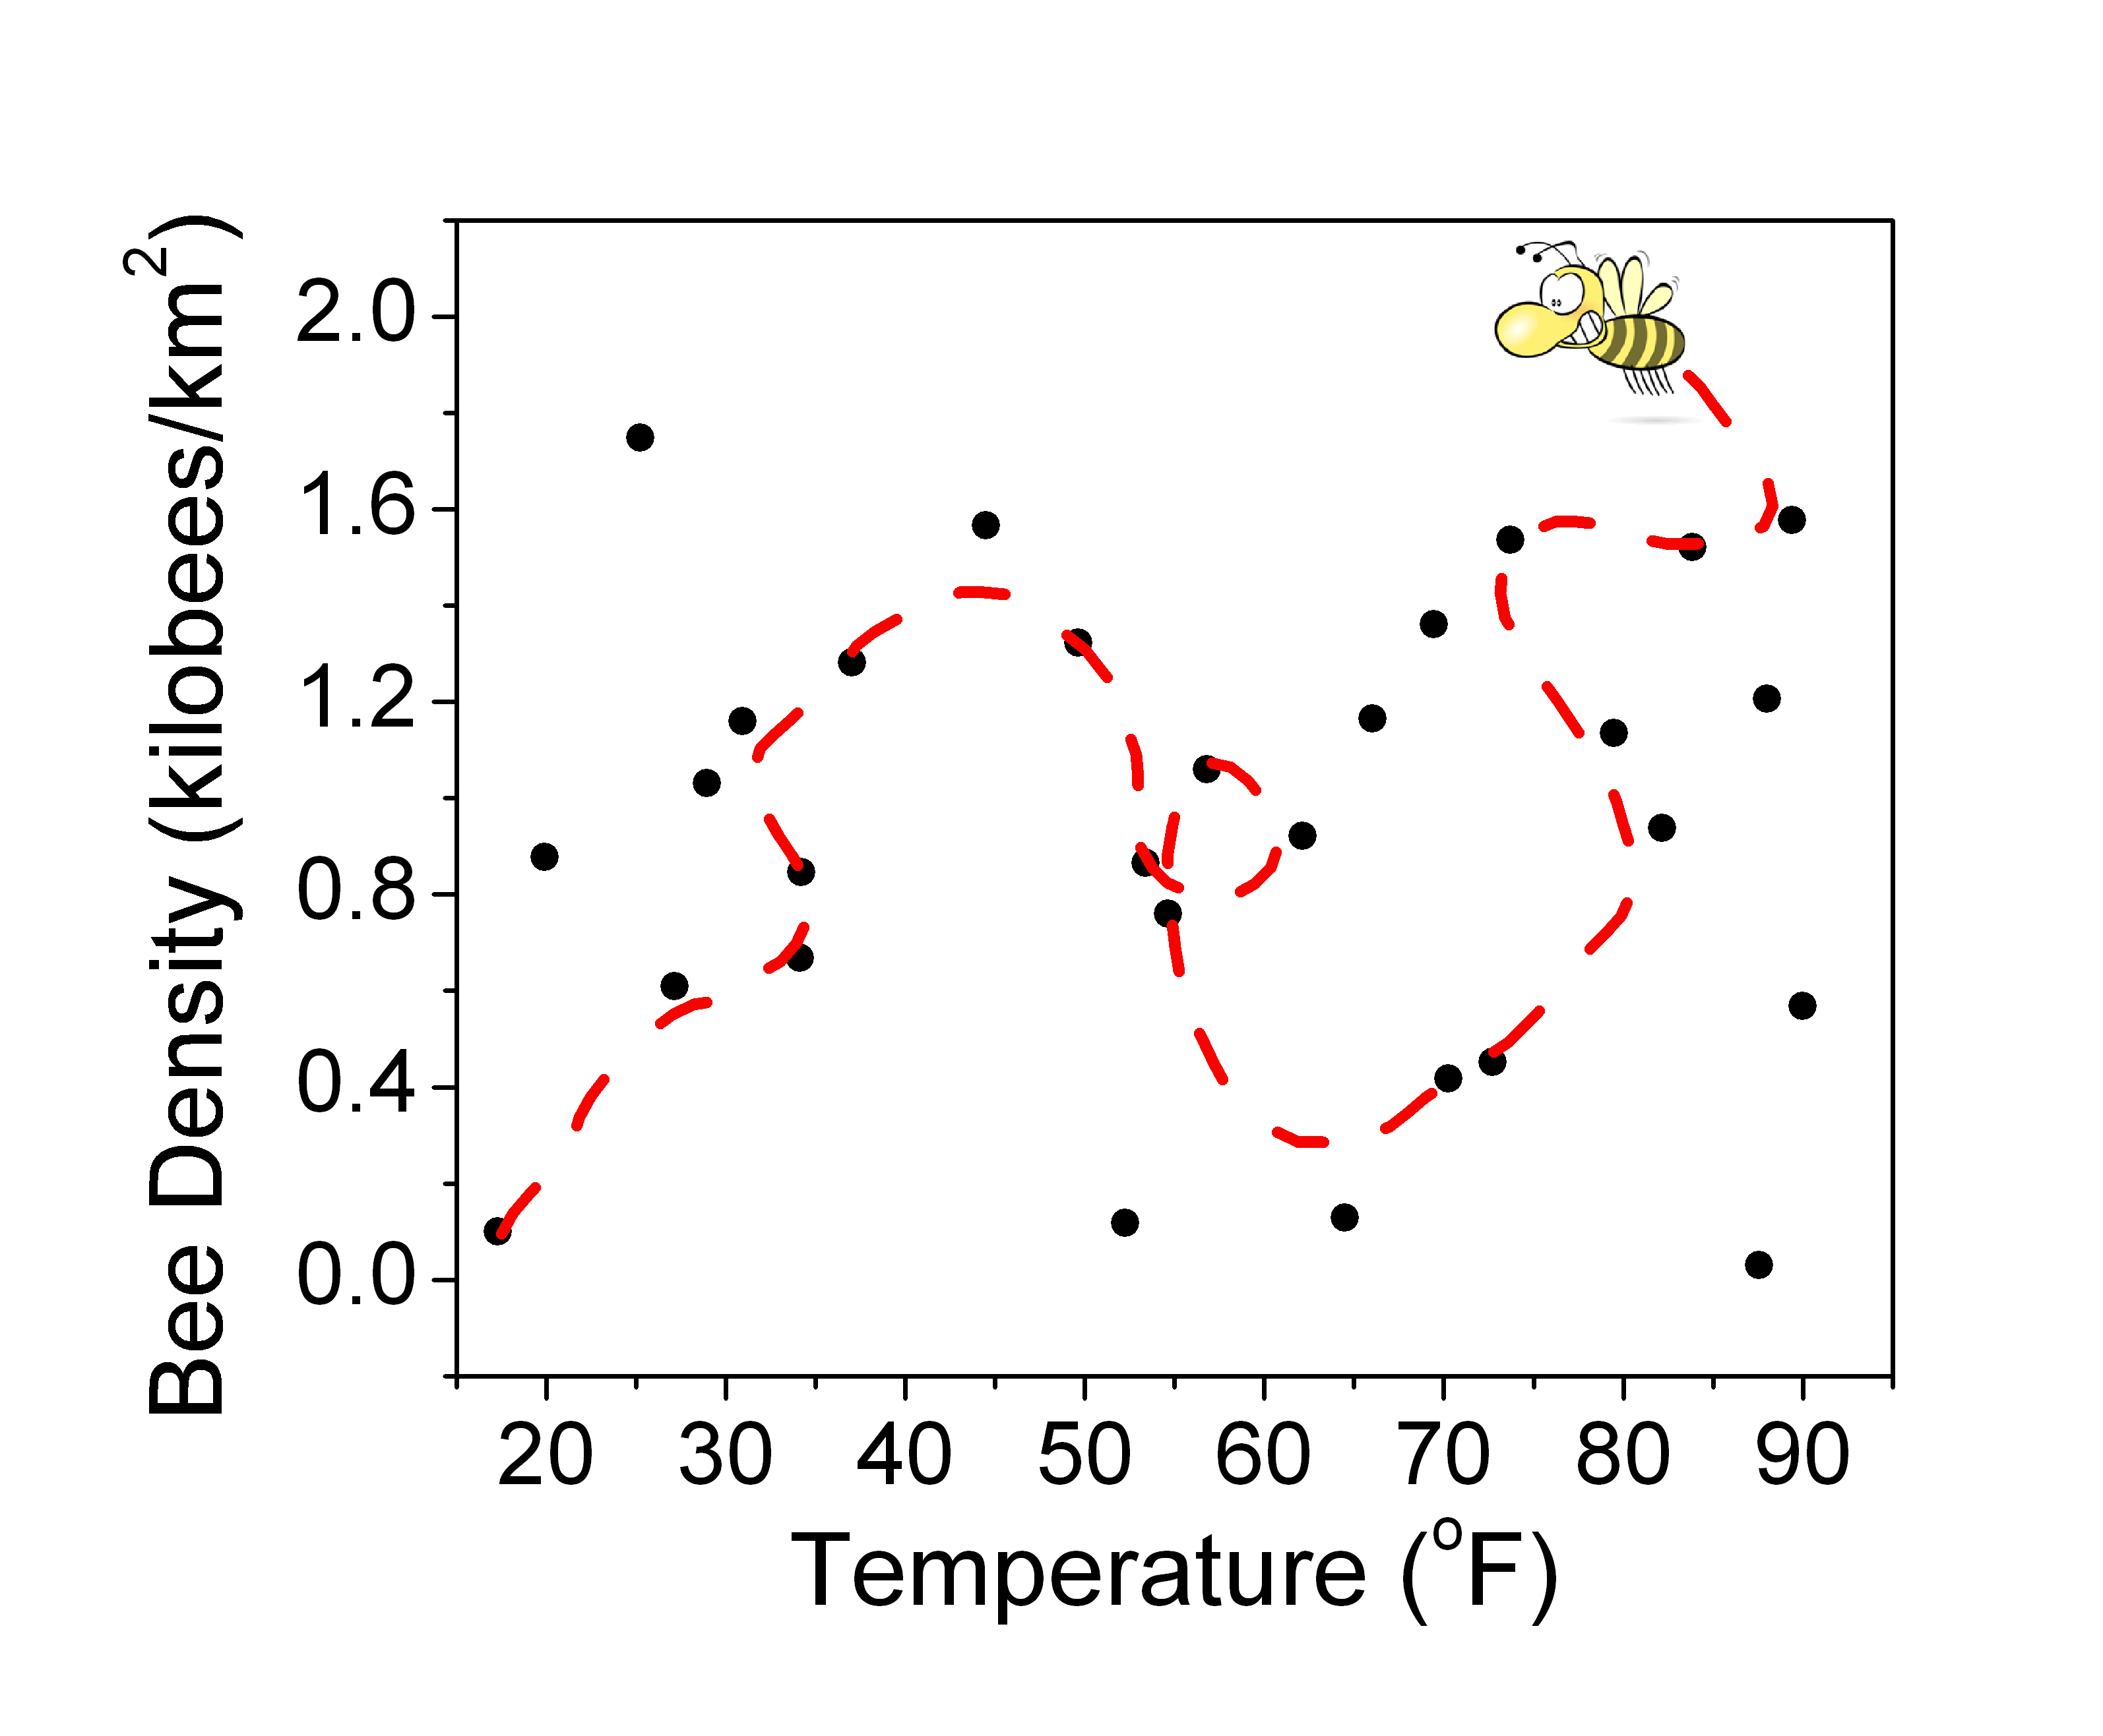
Fig. 1 (A) Bombus terrestris number 20045-B catalog image. (B) Plot of bee density versus temperature. The best fit line was calculated using an advanced nonlinear regression. Text is justified, 10 point Times New Roman. Panel letters (i.e. A and B) are bold and encased in parenthesis. Images of the bees are courtesy of the world wide web.

A
B
[1] Name 1 and Name 2, “Paper title”, Journal title, volume, pages, (year of publication).
[2] Pendry, J. B. “Negative refraction makes a perfect lens” Phys. Rev. Lett. 85, 3966-3969 (2000).

